**Experiment 5**

**Student Name: Sahul Kumar Parida UID: 20BCS4919**

**Branch: CSE Section/Group: WM-904/B**

**Semester: 5th Date of Performance: 08/11/2022**

**Subject Name: Web and Mobile Security Lab**

**Subject Code: 20CSP-333**

**Aim:**

Write a program to generate message digest for the given message using the SHA/MD5 algorithm and verify the integrity of message.

**Software/Hardware Requirements:**

Windows 7 and above version.

**Tools to be used:**

1. Eclipse IDE
2. JDK (Java Development kit)
3. IntelliJ IDEA

**Steps/Method/Coding:**

To calculate cryptographic hashing value in Java, **MessageDigest** Class is used, under the package java.security.

MessageDigest Class provides following cryptographic hash function to find hash value of a text as follows:

* MD2
* MD5
* SHA-1
* SHA-224
* SHA-256
* SHA-384
* SHA-512

1.This Algorithms are initialize in static method called **getInstance()**.

2. After selecting the algorithm it calculates the **digest** value and return the results in byte array.

3. BigInteger class is used, which converts the resultant byte array into its **sign- magnitude representation**.

4.This representation is then converted into a hexadecimal format to get the expected MessageDigest.

Examples:

**Input:** hello world

**Output:** 5eb63bbbe01eeed093cb22bb8f5acdc3

**Input:** GeeksForGeeks

**Output:** e39b9c178b2c9be4e99b141d956c6ff6

**Coding (MD5 algorithm)**

import java.math.BigInteger;

import java.security.MessageDigest;

import java.security.NoSuchAlgorithmException;

// Java program to calculate MD5 hash value

public class MD5 {

public static String getMd5(String input)

{

try {

// Static getInstance method is called with hashing MD5

MessageDigest md = MessageDigest.getInstance("MD5");

// digest() method is called to calculate message digest

// of an input digest() return array of byte

byte[] messageDigest = md.digest(input.getBytes());

// Convert byte array into signum representation

BigInteger no = new BigInteger(1, messageDigest);

// Convert message digest into hex value

String hashtext = no.toString(16);

while (hashtext.length() < 32) {

hashtext = "0" + hashtext;

}

return hashtext;

}

// For specifying wrong message digest algorithms

catch (NoSuchAlgorithmException e) {

throw new RuntimeException(e);

}

}

// Driver code

public static void main(String args[]) throws NoSuchAlgorithmException

{

String s = "GeeksForGeeks";

System.out.println("Your HashCode Generated by MD5 is: " + getMd5(s));

}

}

References:

1. [Java Docs for MessageDigest](https://docs.oracle.com/javase/7/docs/api/java/security/MessageDigest.html)

**2.** [**MD5 hash in Java**](https://www.geeksforgeeks.org/md5-hash-in-java/)

**Coding (SHA algorithm)**

// Java program to calculate SHA-1 hash value

import java.math.BigInteger;

import java.security.MessageDigest;

import java.security.NoSuchAlgorithmException;

public class GFG {

public static String encryptThisString(String input)

{

try {

// getInstance() method is called with algorithm SHA-1

MessageDigest md = MessageDigest.getInstance("SHA-1");

// digest() method is called

// to calculate message digest of the input string

// returned as array of byte

byte[] messageDigest = md.digest(input.getBytes());

// Convert byte array into signum representation

BigInteger no = new BigInteger(1, messageDigest);

// Convert message digest into hex value

String hashtext = no.toString(16);

// Add preceding 0s to make it 32 bit

while (hashtext.length() < 32) {

hashtext = "0" + hashtext;

}

// return the HashText

return hashtext;

}

// For specifying wrong message digest algorithms

catch (NoSuchAlgorithmException e) {

throw new RuntimeException(e);

}

}

// Driver code

public static void main(String args[]) throws

NoSuchAlgorithmException

{

System.out.println("HashCode Generated by SHA-1 for: ");

String s1 = "GeeksForGeeks";

System.out.println("\n" + s1 + " : " + encryptThisString(s1));

String s2 = "hello world";

System.out.println("\n" + s2 + " : " + encryptThisString(s2));

}

}

**Output screenshot:**

**OUTPUT using MD5**

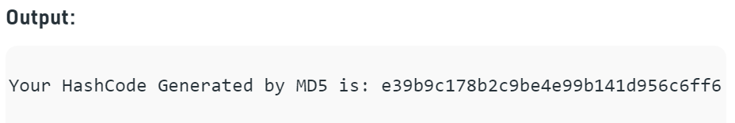

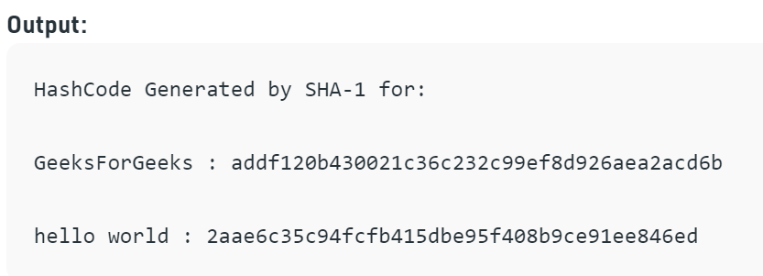

**Learning Outcomes:**

Output is often known as hash values, hash codes, message digest. The length of output hashes is generally less than its corresponding input message length.